Grooming examples
This is a Kennel Cut using a #5 blade or shorter:
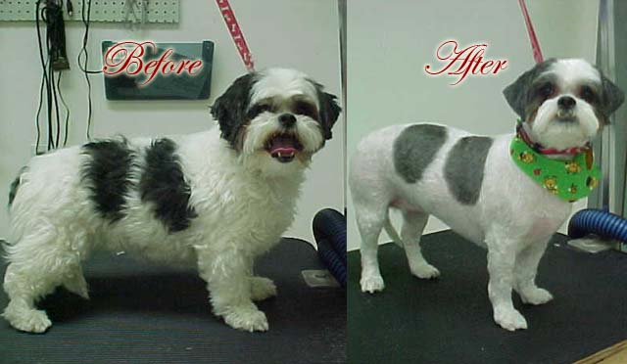
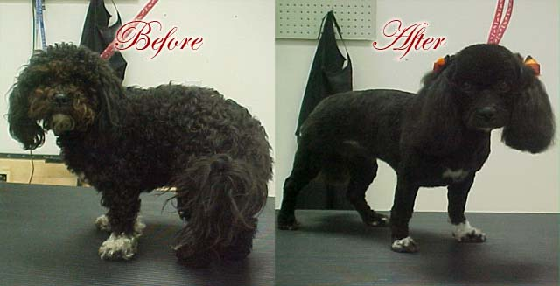

This is a Teddy Bear Cut. Everything is pretty much rounded and the legs are slightly longer then the body:
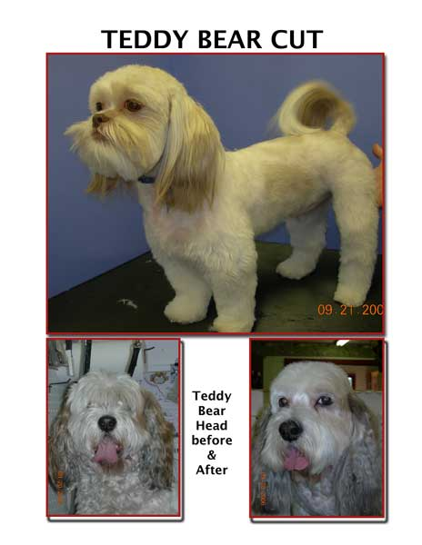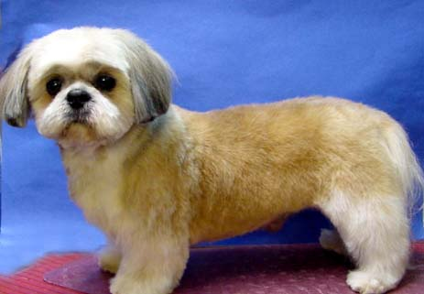

Labradoodle Teddy Bear cut:
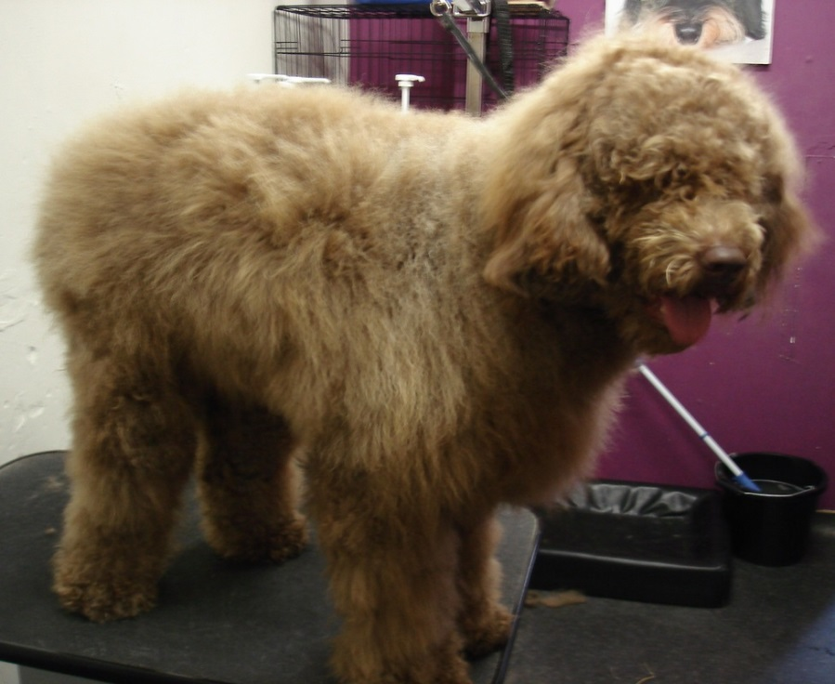: Before
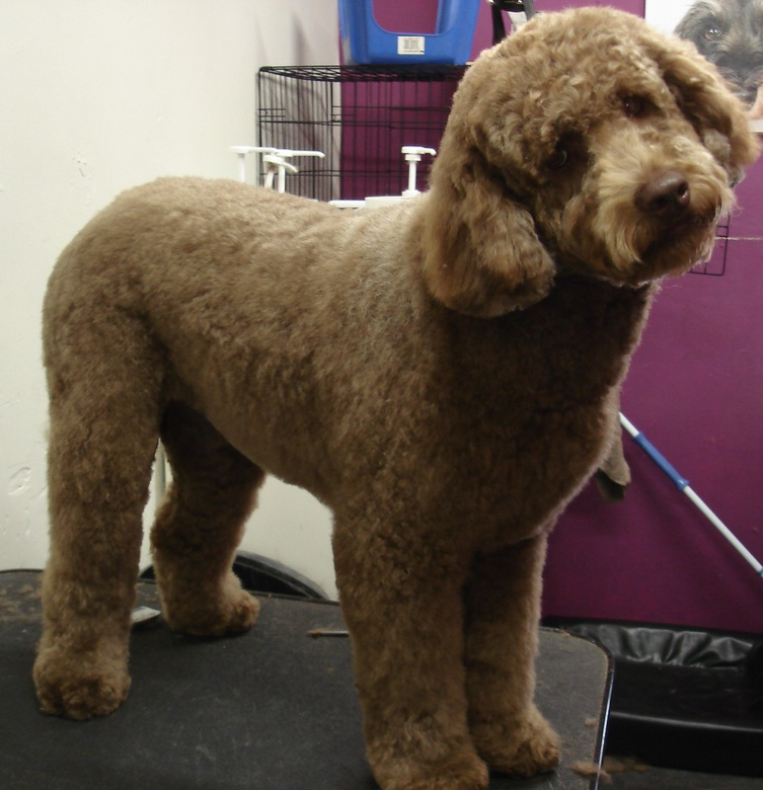: After

This is a Breed Cut. All breed cuts are cut according to the breed:
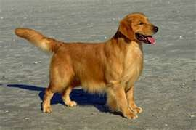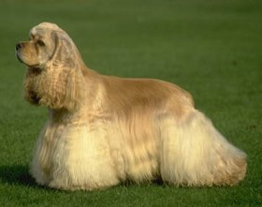
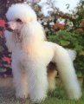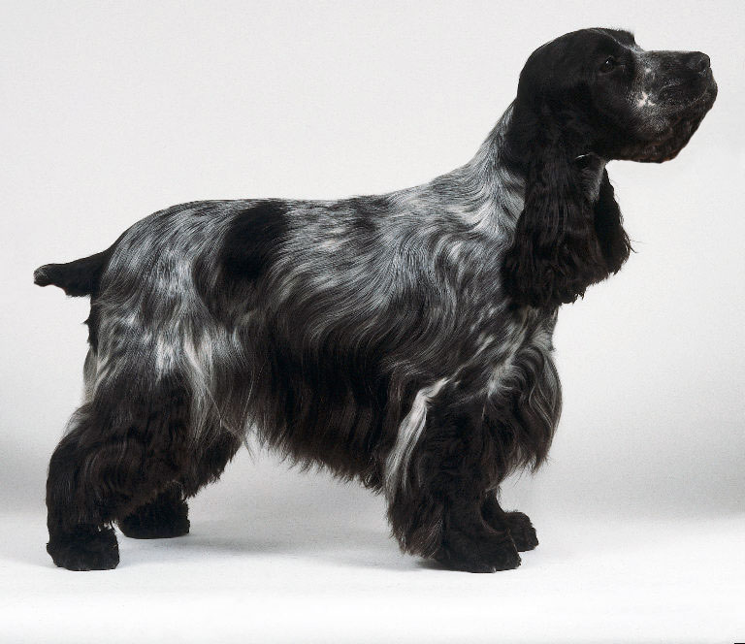
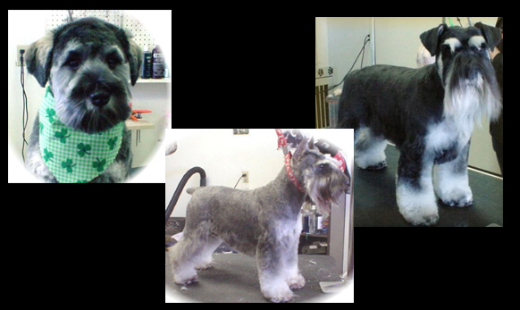
A Bath and tidy is simply tidying up the feet and face. This includes Bath, brush, nails, face and ear plucking (For the dogs that need it). All dogs can get a bath and tidy.
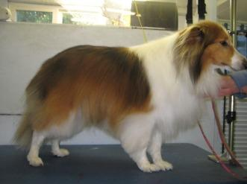

A dog that has been shaved, the blade used is a #10. But any blade 7 and up are considered shaving which leaves the hair very close to the body.
